
Inventory Reservation System for Retailers


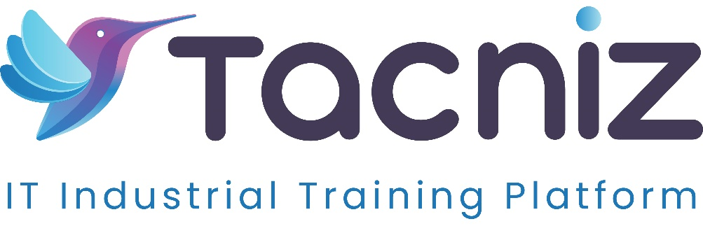

Problem Statement
In today’s retail environment, many customers prefer to reserve items online and pick them up in-store or at a designated location. However, many retailers struggle with managing real-time inventory for these reservations. Without an efficient system, retailers may oversell stock, leading to customer dissatisfaction and potential loss of sales. A streamlined online reservation system that tracks item availability in real time, reserves stock for customers, and integrates with the store’s inventory management system can ensure seamless operations and an enhanced customer experience.

Project Type
- Type: Online Inventory Reservation System
- Category: Retail Inventory Management, E-commerce

Industry Area
- Industry: Retail, E-commerce, Wholesale
- Relevant Sectors: Inventory Control, Customer Service, Store Operations

Software Expertise Required
- Frontend Development: HTML, CSS, JavaScript (React, Vue, or Angular) to build an easy-to-use interface for customers to browse available items, reserve products, and schedule pick-ups.
- Backend Development: Node.js / Python (Django/Flask) to manage inventory data, handle customer reservations, and synchronize the system with existing inventory management tools.
- Database Management: SQL or NoSQL databases (e.g., MySQL, MongoDB) to store product availability, customer reservations, and order status in real-time.
- API Integration: Integration with existing point-of-sale (POS) or inventory management systems to update stock levels instantly after a reservation is made.
- Cloud Integration: AWS, Google Cloud, or Azure for real-time data processing, reservation tracking, and storage scalability.
- Notifications and Alerts: Email or SMS integration for confirming reservations and sending reminders to customers before pick-up.

Use Cases
- Retail Customers: Reserve products online, ensure item availability, and pick them up at a later time from the store or a designated location.
- Retail Stores: Track reserved items in real time, avoid stockouts or overselling, and manage in-store or curbside pickups efficiently.
- E-commerce Platforms: Offer customers an online-to-offline (O2O) shopping experience by reserving products for in-store pickup while keeping stock levels synchronized.

Expected Outcomes
- Improved Customer Experience: Customers can reserve items online, guaranteeing availability, and choose convenient pick-up times, improving satisfaction and loyalty.
- Accurate Stock Management: The system will update inventory in real-time, ensuring that items reserved are not sold to other customers, reducing the risk of stockouts or overselling.
- Increased Sales: By allowing customers to reserve items online, retailers can capture additional sales that might be lost due to out-of-stock issues or long wait times in-store.
- Seamless Integration: Integration with existing inventory and POS systems will ensure that store operations remain smooth, with up-to-date inventory data.

Key Features
- Real-Time Inventory Tracking: Customers can view up-to-date product availability before reserving items online, ensuring that only in-stock items are reserved.
- Reservation System: Customers can reserve products online, specifying a preferred pick-up time and location (in-store or curbside).
- Integration with Inventory Systems: The system will synchronize with the retailer’s existing inventory management or POS system, automatically adjusting stock levels when reservations are made.
- Reservation Confirmation: The system will send automated email or SMS notifications to customers to confirm reservations and remind them of upcoming pick-up times.
- Customer Management Dashboard: Retail staff can view and manage all active reservations, including customer details, reserved products, and scheduled pick-up times.
- Reservation Expiry: The system can automatically release reserved items back into inventory if a customer does not pick them up within a specified time frame.

Benefits
- Convenience for Customers: The system offers customers the flexibility to reserve items online, avoiding the hassle of in-store browsing or dealing with out-of-stock issues.
- Enhanced Stock Control: Real-time integration ensures that inventory levels are accurate and up-to-date, reducing discrepancies and stock-related issues.
- Boost in Revenue: The reservation system allows retailers to capture sales that might otherwise be lost due to stockouts or customer indecision, increasing overall revenue.
- Reduced Operational Burden: The system automates inventory updates and reservation management, freeing up staff to focus on other important tasks.
- Flexibility for Retailers: Retailers can offer additional services like in-store or curbside pickup, enhancing the overall customer shopping experience.

Project Duration
- Estimated Duration: 5-6 Months.

